Jackson m- I Love This Photo Its Very Nice I Love The Shadows And Everything About It I Like How The Background Is Bury And It Looks Very Cool.
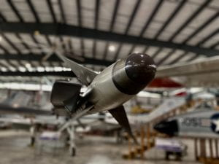

Mckenna- I love this photo its very nice with the angle. I love the color of the vechle and everything about the photo its very nice good job.

Clara- I like this photo its very nice. I like how you just got the front of the plane its very cool. I love the angle how you got below it. Nice job
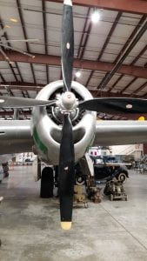

Stephine- I love this photo very much. I love the shadows on this photo and the angles you got are good as well. Good job drawing the smiley face too.

